User Login Interface Prototype
https://www.figma.com/make/iMT5jNDsBpYH7pJhQizVci/University-Clinic-Login-Screen?t=ml44WWpZcmkf69jt-1
3.1 Introduction
The User Login Interface Prototype was developed for the Taylor’s University Health & Wellness Centre Student Appointment Portal. This interface provides a secure way for students to log in to the system.
The primary goal of this interface is to ensure that only authorized individuals can access their health information, make appointments, and manage their medical records.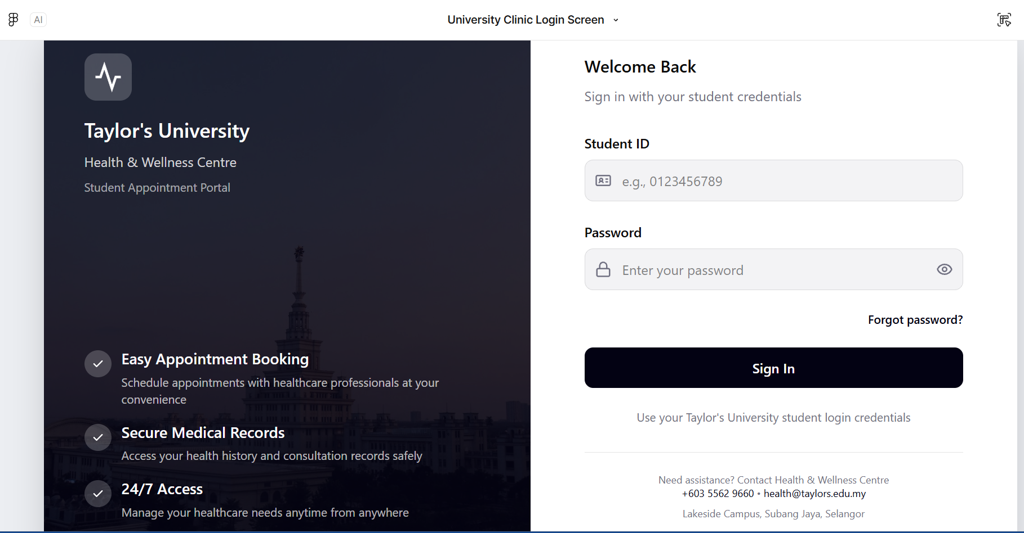
The Interface Description
The Login Screen has two major Areas: An Area of information on the Left Side of the Screen and an Area for Logging in on the Right Side of the Screen.
Information Area:
-The Left side of this interface displays:
- The University Name and System Title
- A Short Description of the Health & Wellness Centre Portal.
- Important Features including: - Simple Appointment Scheduling, Confidential Medical Records, Access 24 hours a Day, 7 days a Week.
The Information Side provides information to enable the user to understand the purpose of the system and build confidence about using the system prior to logging in.
Login Area:
- The Right side of the interface contains the login form where students enter their credentials, including:
- Student ID Field: The student will enter their Student ID number example of valid Student ID numbers to assist with proper entry.
- Password Field: The student will enter their password in a secure password field. The password will be hidden when entered for privacy. A student has the option of displaying/hiding their password when logging into the Health & Wellness Centre portal.
- Forgot Password Link: Provides students assistance when they have forgotten their passwords and requires a password reset.
- Sign In Button: By pressing this button, the user submits their login Credentials and is allowed access to the Health and Wellness Centre Portal.
- Support contact information: This section of the interface provides students with contact information in case they require assistance using the Health and Wellness Centre Portal.

Usability characteristics
Usability Features:
The User Login Interface Prototype was designed to be easy-to-use and straightforward. Some of the critical usability features are:
- Placement of input fields that have been labelled clearly.
- Layout that has been arranged neatly and clearly so as not to confuse the user.
- Fonts that are not difficult to read.
- Strong contrast for the Login button.
- Minimal design to cut down on confusion.
These usability features help students log into the portal without any difficulty and/or delay.

Security Considerations
As the User Login Interface Prototype has access to confidential medical information, it is essential that it has a secure design. Some of the important features of security for this system are:
- Only currently enrolled students may access the portal via the User Login Interface Prototype.
- Passwords are hidden as they are being entered into the system.
- Unauthorized users may not easily gain access via the User Login Interface Prototype.

These features assist in maintaining student confidentiality and protecting their medical data

Conclusion
The User Login Interface Prototype has been designed to provide a secure and easy-to-use way for students to log into the Health and Wellness Centre via the University Healthcare System. The design focuses on ease of use for all types of users (both users who are new to using a computer, as well as advanced users), accessibility, and protecting user data. Therefore, it is appropriate for the university healthcare system.

